|  |  |  |  |  |  |  |
| --- | --- | --- | --- | --- | --- | --- |
| **Mehran University of Engineering & Technology,**  **Jamshoro** | |  | **Subject** | | | |
| **Web Technology** | | | |
| **Department of:**  **Bachelor of Science Computer Science** | | **Year** | **2nd** | **Semester** | **3rd** |
| **Roll No:** | **20BSCS043** | **Batch** | **20BSCS** | **Duration** | **3 Hours** |

# PRACTICAL # 5

**TO MANIPULATE THE VARIOUS FORMS ELEMENTS**

**LAB TASKS**

**Task # 1:** Make dropdown, as shown below

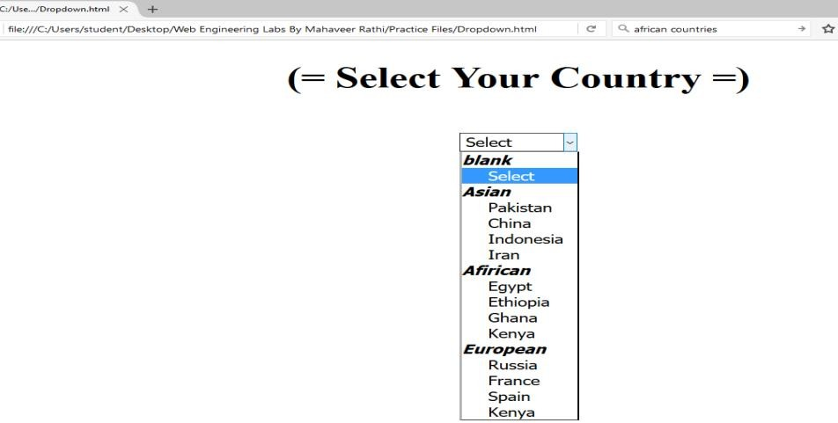

**Code:**

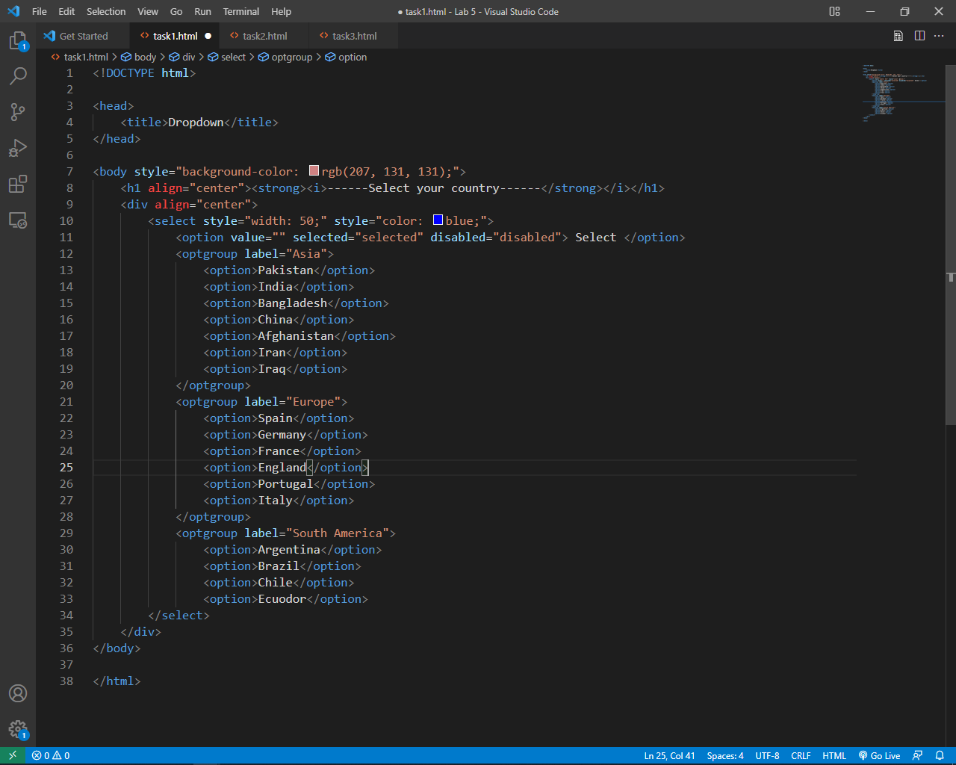



**Output:**

**Task # 2:** Make HTML form, as shown below

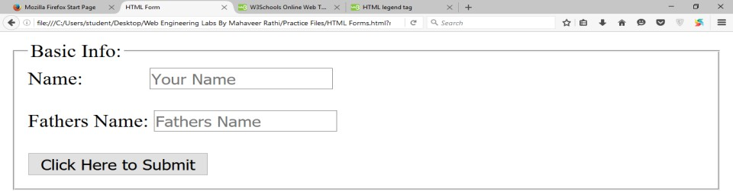

**Code:**

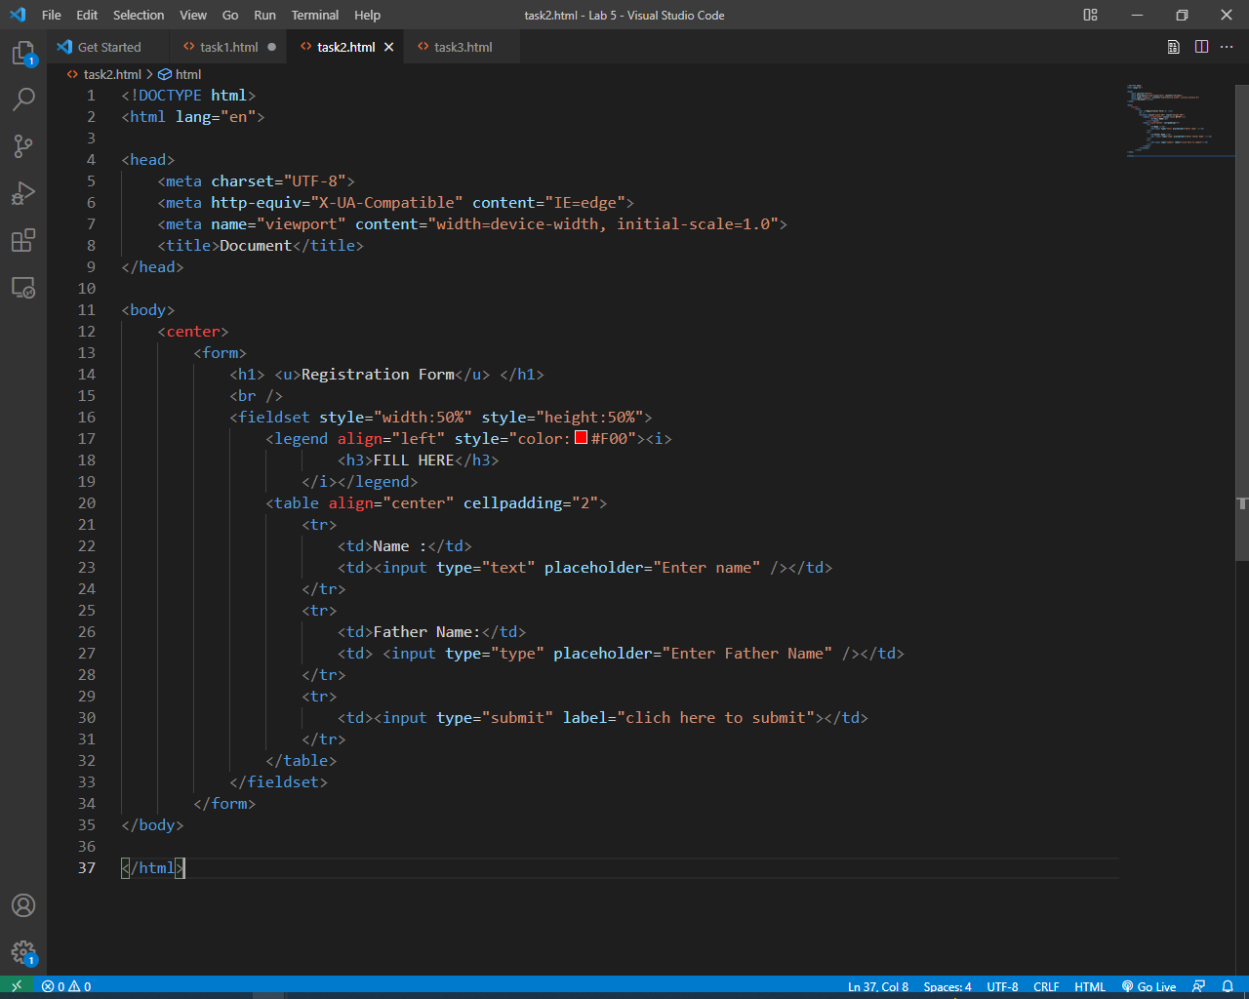

**Output:**

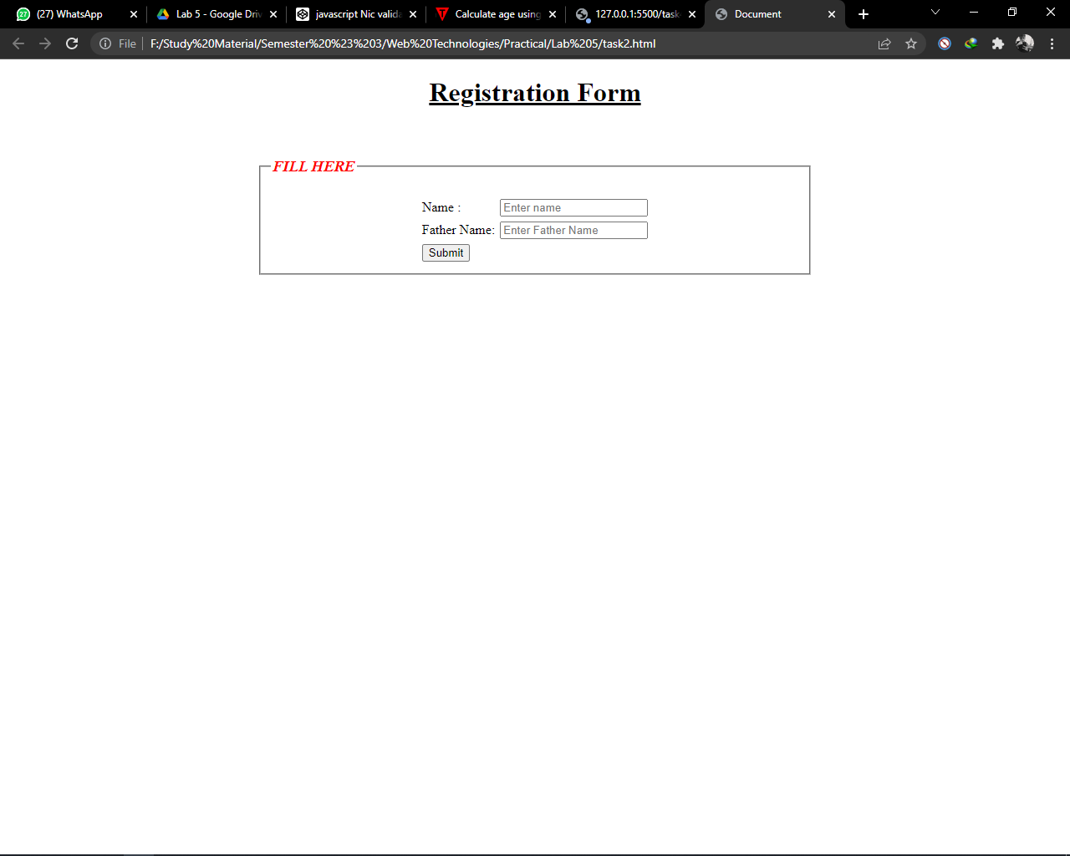

**Task #3:** Create a HTML form in which at least 5 different form elements must be used.

**Code:**

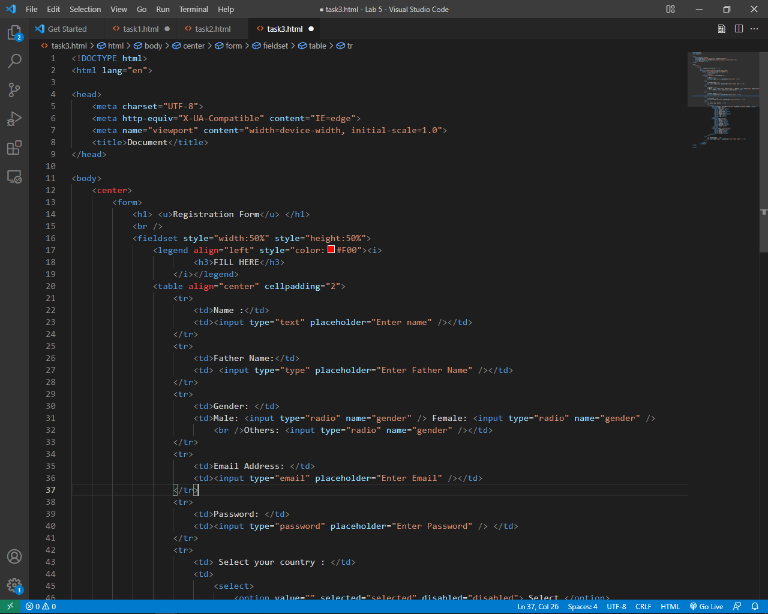

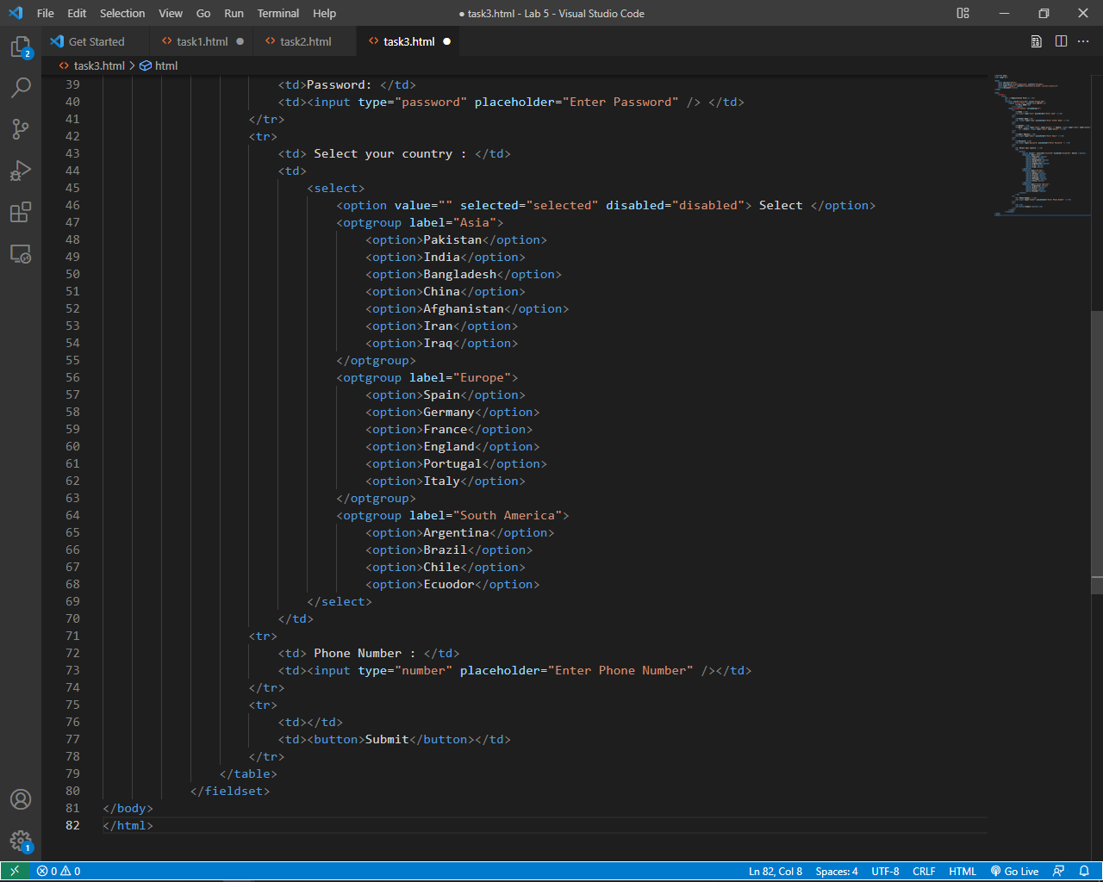

**Output:**

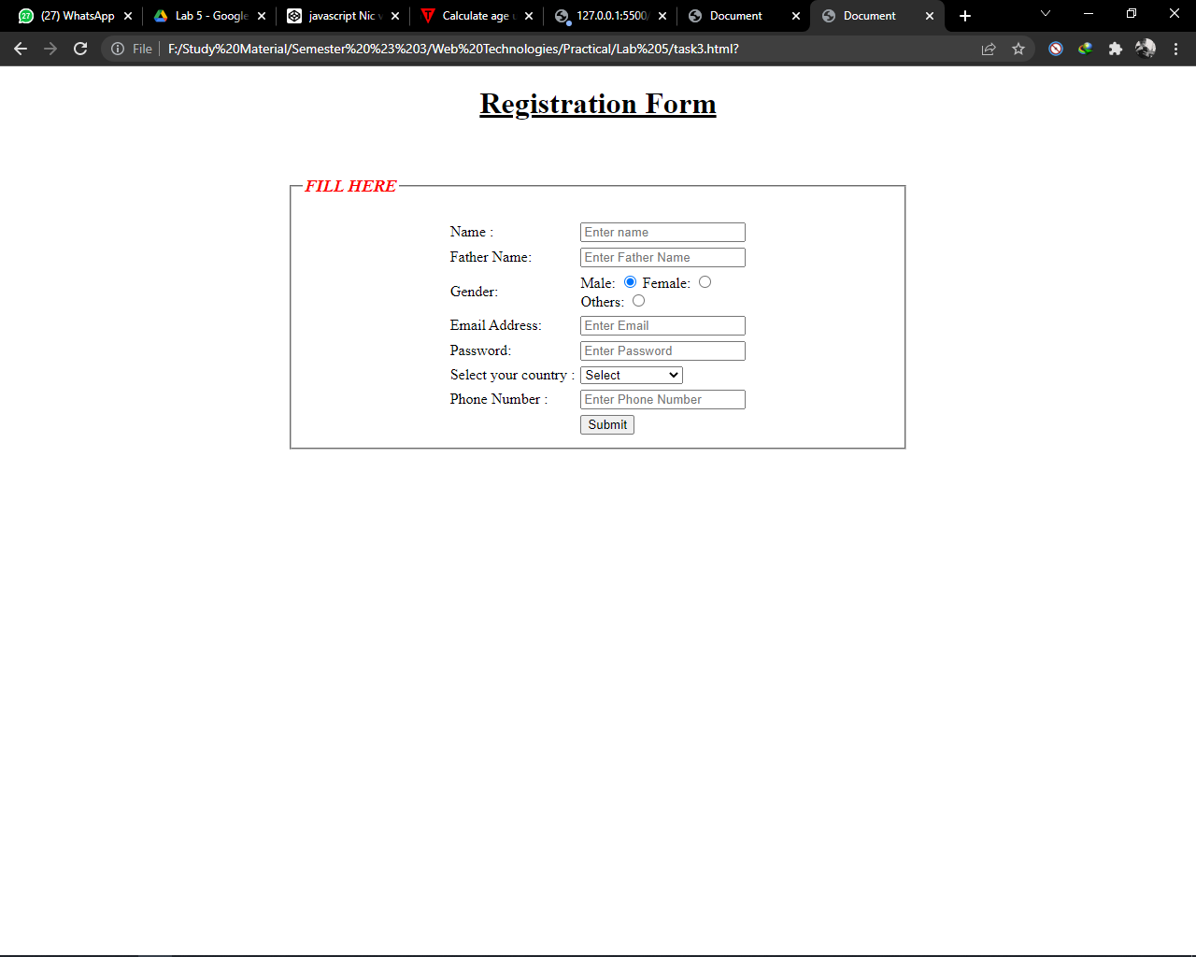

**Task #4:**

What is difference between get and post method describe briefly? Discuss with the help of example. Can we send the form data to another html page without get and post methods? If yes, then how? If No, then Why?

**Answer:**

In get method the data is sanded to the server by embedding it in URL whereas the POST method is used to send the data by embedding it, and no personal details will be displaced inside the URL

Example:

**Task #5:**

What is difference b/w <input type=” button” > and <input type=” submit”>? Discuss with the help of example.

**Answer:**

The input type= ”button” is used an simple ordinary button created by form tag but, the input type= ”Submit” button is used to send data to the server by the action attribute written in the form tag.